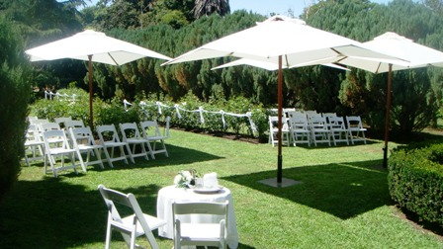  2024 Price list |  | Small  Wedding  Less than 50  People on site | Large  Wedding  More than 50  People on site
- Venue hire for up to three hours  - Outdoor photography rights  - Toilet facilities  - signatory table and 2 chairs  - Venue hosts  - Decorations  - Event notice board |  | $1300 | $1600
Quality white wedding chairs Supplied and set up  48 available | $10 each
Large white market umbrellas  Supplied and set up  4 available | $100 each
Wedding Car and driver  - One way  - local pick up only | $400
Wedding Car and driver  - one way  - local drop off only | $400
TOTAL

Please note the following conditions:
We specialise in hosting the wedding ceremony and photography only. The reception needs to be held elsewhere
Our permit does not allow for any food or alcohol to be consumed on the premises.
Venue hire is strictly for a maximum period of 3 hours from arrival of guests to departure of bride and groom.
Our wedding season runs from late October to early March.
There is no extra fee for the initial viewing or for the wedding rehearsal.
$400 deposit to secure booking is NON refundable. A transfer to another date is subject to availability
Somerset Guest Suite is strictly for accommodation and cannot be used as a dressing room or for hair and makeup.
Lyn and Matt Egan
0412929103 info@sunnysidevilla.com.au www.sunnysidevilla.com.au

